**HUMS1006 Day 3 Lecture Worksheet**

**Eg. #1 Bill Clinton - notice what you notice about how his body is communicating**

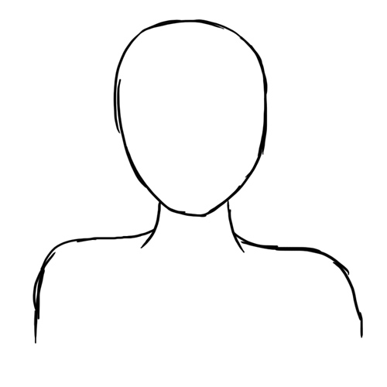

**Eg. #2 Amir Kassir - What is her body saying? Without knowing what she is saying, write a brief passage that *could* be the words that accompany her body language:**

__________________________________________________________________________________

__________________________________________________________________________________

__________________________________________________________________________________

__________________________________________________________________________________

__________________________________________________________________________________

__________________________________________________________________________________

__________________________________________________________________________________

__________________________________________________________________________________

__________________________________________________________________________________